**STUDENT ASSESSMENT SUBMISSION AND DECLARATION**

When submitting evidence for assessment, each student must sign a declaration confirming that the work is their own.

|  |  |  |  |
| --- | --- | --- | --- |
| **Student name:** | | **Assessor name**: Mrs. ALF. Sajeetha | |
| **Issue date:**  13.06.2024 | **Submission date:**  31.07.2024 | | **Submitted on:** |
| **Programme:**  Higher Nationals in Computing | | | |
| **Unit:**  01. Programming | | | |
| **Assignment number and title:**  Bespoke Software Solution for North Sys Judo (pvt) Ltd | | | |

**Plagiarism**

Plagiarism is a particular form of cheating. Plagiarism must be avoided at all costs and students who break the rules, however innocently, may be penalized. It is your responsibility to ensure that you understand correct referencing practices. As a university-level student, you are expected to use appropriate references throughout and keep carefully detailed notes of all your sources of materials for material you have used in your work, including any material downloaded from the Internet. Please consult the relevant unit lecturer or your course tutor if you need any further advice.

**Student Declaration**

**Student declaration**

I certify that the assignment submission is entirely my own work and I fully understand the consequences of plagiarism. I understand that making a false declaration is a form of malpractice.

Student signature: Date:

|  |  |  |  |  |  |  |
| --- | --- | --- | --- | --- | --- | --- |
| **ASSESSMENT TRACKING** | | | | | | |
| Program: | Higher Nationals in Computing | | Student Name: |  | | |
| Unit  No. &  Title: | 01. Programming | | Assessment Date: | 13.06.2024 | Unit Grade: |  |
| Assess  or  Name: | Mrs. A.L.F. Sajeetha | | Completion Date | 31.07.2024 | IV Signature: | [jubailah@bcas.lk](mailto:jubailah@bcas.lk) |
| Tasks | Learning Objective | Criteria Targeted | Date Issued | Hand in Date | Formative Feedback  date | Resubmission  date |
| Task 1 | LO1 | P1  P2  M1  D1 | 13.06.2024 | 21.06.2024 | 23.06.2024 | 25.06.2024 |
| Task 2 | LO2 | P3  M2  D2 | 28.06.2024 | 30.06.2024 | 01.07.2024 |
| Task 3 | LO3 | P4  M3  D3 | 14.07.2024 | 16.07.2024 | 18.07.2024 |
| Task 4 | LO4 | P5  P6  M4  D4 | 21.07.2024 | 23.07.2024 | 31.07.2024 |

**Unit 01: Programming**

**Assignment Brief**

|  |  |
| --- | --- |
| Student Name/ID  Number |  |
| **Unit Number and Title** | **01. Programming** |
| Academic Year | **2024** |
| Batch No/ Cohort & Semester | **Batch 22, Semester 01** |
| Unit Tutor | **Mrs. A.L.F. Sajeetha** |
| **Assignment Title** | **Bespoke Software Solution for North Sys Judo (pvt) Ltd** |
| Issue Date | **13.06.2024** |
| Submission Date | **31.07.2024** |
| **Submission Format** | |
| **Task 1:** Report  **Task 2:** Report  **Task 3:** Report, attach the source code, and screenshot your output  (You are suggested to implement program using a PyCharm IDE with Python language and as you all were advised to create your own Github Account in the academic hours, upload the developed source code in the Github Repository and shared the Repository’s link in the report)  **Task 4:** Report | |
| **Unit Learning Outcomes** | |
| **LO1** Define basic algorithms to carry out an operation and outline the process of programming an application.  **LO2** Explain the characteristics of procedural, object-orientated and event-driven programming.  **LO3** Implement basic algorithms in code using an IDE.  **LO4** Determine the debugging process and explain the importance of a coding standard. | |
| **Transferable skills and competencies developed** | |
| On successful completion of this Assessment, student:   * Will be able to design and implement algorithms in a chosen language in a suitable Integrated Development Environment (IDE). * Communication literacy * Critical thinking * Analysis * Reasoning and Interpretation | |
| **Vocational scenario** | |
| You have just started a new role as a **Junior Software Developer at AQ Digital Solutions** (AQDS), an independent software development company that designs and builds **bespoke software solutions** for various companies of different sizes that cover a range of different industries. The software that they design uses a wide range of technologies, from simple stand-alone programs to large web-based applications.  AQDS has been approached by a small, local company called **North Sys Judo** that specializes in providing judo training sessions to people from the local community. North Sys Judo caters to people of all ages and experience, from experts to beginners.  **North Sys Judo has requested a simple program that will calculate the cost of training fees for their athletes each month and the following features should be added.**   1. Athletes can receive a maximum of five hours’ private coaching a week 2. Only Intermediate and Elite athletes can enter competitions 3. Competitions are held on the second Saturday of each month 4. All prices and costs should be displayed as currency to two decimal places 5. The program deals with user error by displaying suitable messages to the user and then prompting them for another go 6. North Sys Judo assumes that a month consists of four weeks.  |  |  | | --- | --- | | **Additional Information** | | | **Training Plan – Prices (Rs.)** | | | Beginner (2 Session per week) - weekly fee | Rs. 2000 | | Intermediate (3 session per week) - weekly fee | Rs. 5000 | | Elite (5 session per week) | Rs. 7000 | | Private tuition – per hour | Rs. 500 | | Competition entry fee – per competition | Rs. 2500 | | **Weight Categories** | | | **Categories** | **Upper weight limit (kg)** | | Heavyweight | Unlimited (over 100) | | Light - Heavyweight | 100 | | Middleweight | 90 | | Light-Middleweight | 81 | | Lightweight | 73 | | Flyweight | 66 |   **Requirement 01:** The requirements are that North Sys Judo wants a program that will allow a user to enter the following information.   1. Athlete name: 2. Training plan: 3. Current weight in kilograms (kg): 4. Competition weight category: 5. Number of competitions entered this month: 6. Option to add the number of hours private coaching:   **Requirement 02:**  For each athlete, the program should then output the following information:   1. The athlete’s name: 2. A break down list of all costs for the month: 3. The total cost of training and competitions for the month: 4. How their current weight compares to their competition weight category:   North Sys Judo currently has six athletes enrolled on their training program, but they would like the ability to register more. You should use the additional information on the **above table** to help you when developing your program.  Consequently, the company's CEO reviewed the client requirements and determined that this is a suitable project for you to take on. The company wants to see how you use and apply the ADQS development environments and code standards.  Also, the client has not specified any Graphical User Interface, but the CEO has left the program design up to you. Once the program has been built, the CEO has asked you to report back to them on how you designed and developed the algorithms required, as well as how you converted these algorithms into a final program and to show any issues you encountered.  Also, as part of your report, the CEO wants you create a presentation for the development team showing the different programming paradigms available, as well as the debugging tools you used as part of the program development, so that the development team can review your progress. | |
| **Assignment activity and guidance** | |
| **Task 1**  Based on the given scenario, you are required to,   1. Define an algorithm and outline the process of building the Application. 2. Determine the steps taken from writing code up to the execution step. 3. Analyse the process of writing code, including the potential challenges faced.     **Task 2**  Produce a formal report (with supporting notes) for AQDS that explores the features and characteristics of the three different programming paradigms. Procedural, Object Oriented and Event-driven in any selected application by you. The selected application source code needs to be implemented in all three paradigms.  Your report should include:   1. a brief explanation about what the selected application is and what it does 2. a general discussion of the three code paradigms, with specific reference to their characteristics and how each one is related 3. a comparison of how these three programming paradigms have been used to implement the source code for the given application in terms of code structure and characteristics.     **Task 3**  You are required to **develop a program** for North Sussex Judo that makes use of appropriate algorithm which is already given by you in task 1.1 to fulfil the given client requirements. You should make use of whichever tools and techniques are most appropriate for your chosen coding paradigm from task 2.1 and for the nature of your **software solution**.  Also, you are to write a report detailing the process required to turn the algorithm into a working application. Your report should include the following.   1. A description of the steps required for converting the algorithm into a working program, including identification of a suitable programming language 2. Evaluate the implementation of the above algorithm have defined (task 1.1) by you, in a suitable language and the relationship between the written algorithm and the code variant. (e.g. parts of the algorithm that would remain the same, changes that would have to be made) 3. An analysis of the possible challenges you have faced when converting the designed algorithm into program code (e.g. data types/structures available in the chosen language, control structures, Programming paradigms required) 4. An explanation of the coding standards you used in your source code.   **Task 04**  As part of your written report, you should clearly show how you have enhanced your original program, using the features of the IDE to manage the development process. This could include:   1. Identifying and solving any logical errors in the original program 2. Debugging any errors in the program 3. Using version control within your IDE to track and monitor changes in the program 4. Using performance monitoring tools to optimize the program 5. Refining and optimizing the program using different code constructs. 6. Include your final, annotated source code and working application as part of your report. | |
| **Recommended Resources:** | |
| * Aho, A. V. et al. (1987) Data Structures and Algorithms. 1st ed. AddisonWesley. * Hunt, A. et al. (2000) The Pragmatic Programmer: From Journeyman to Master. 1st ed. Addison-Wesley. * McConnell, S. (2004) Code Complete: A Practical Handbook of Software Construction. 2nd ed. Microsoft Press.   **Please note that the resources listed are examples for you to use as a starting point in your assessment – the list is not definitive.** | |

**Learning Outcomes and Assessment Criteria**

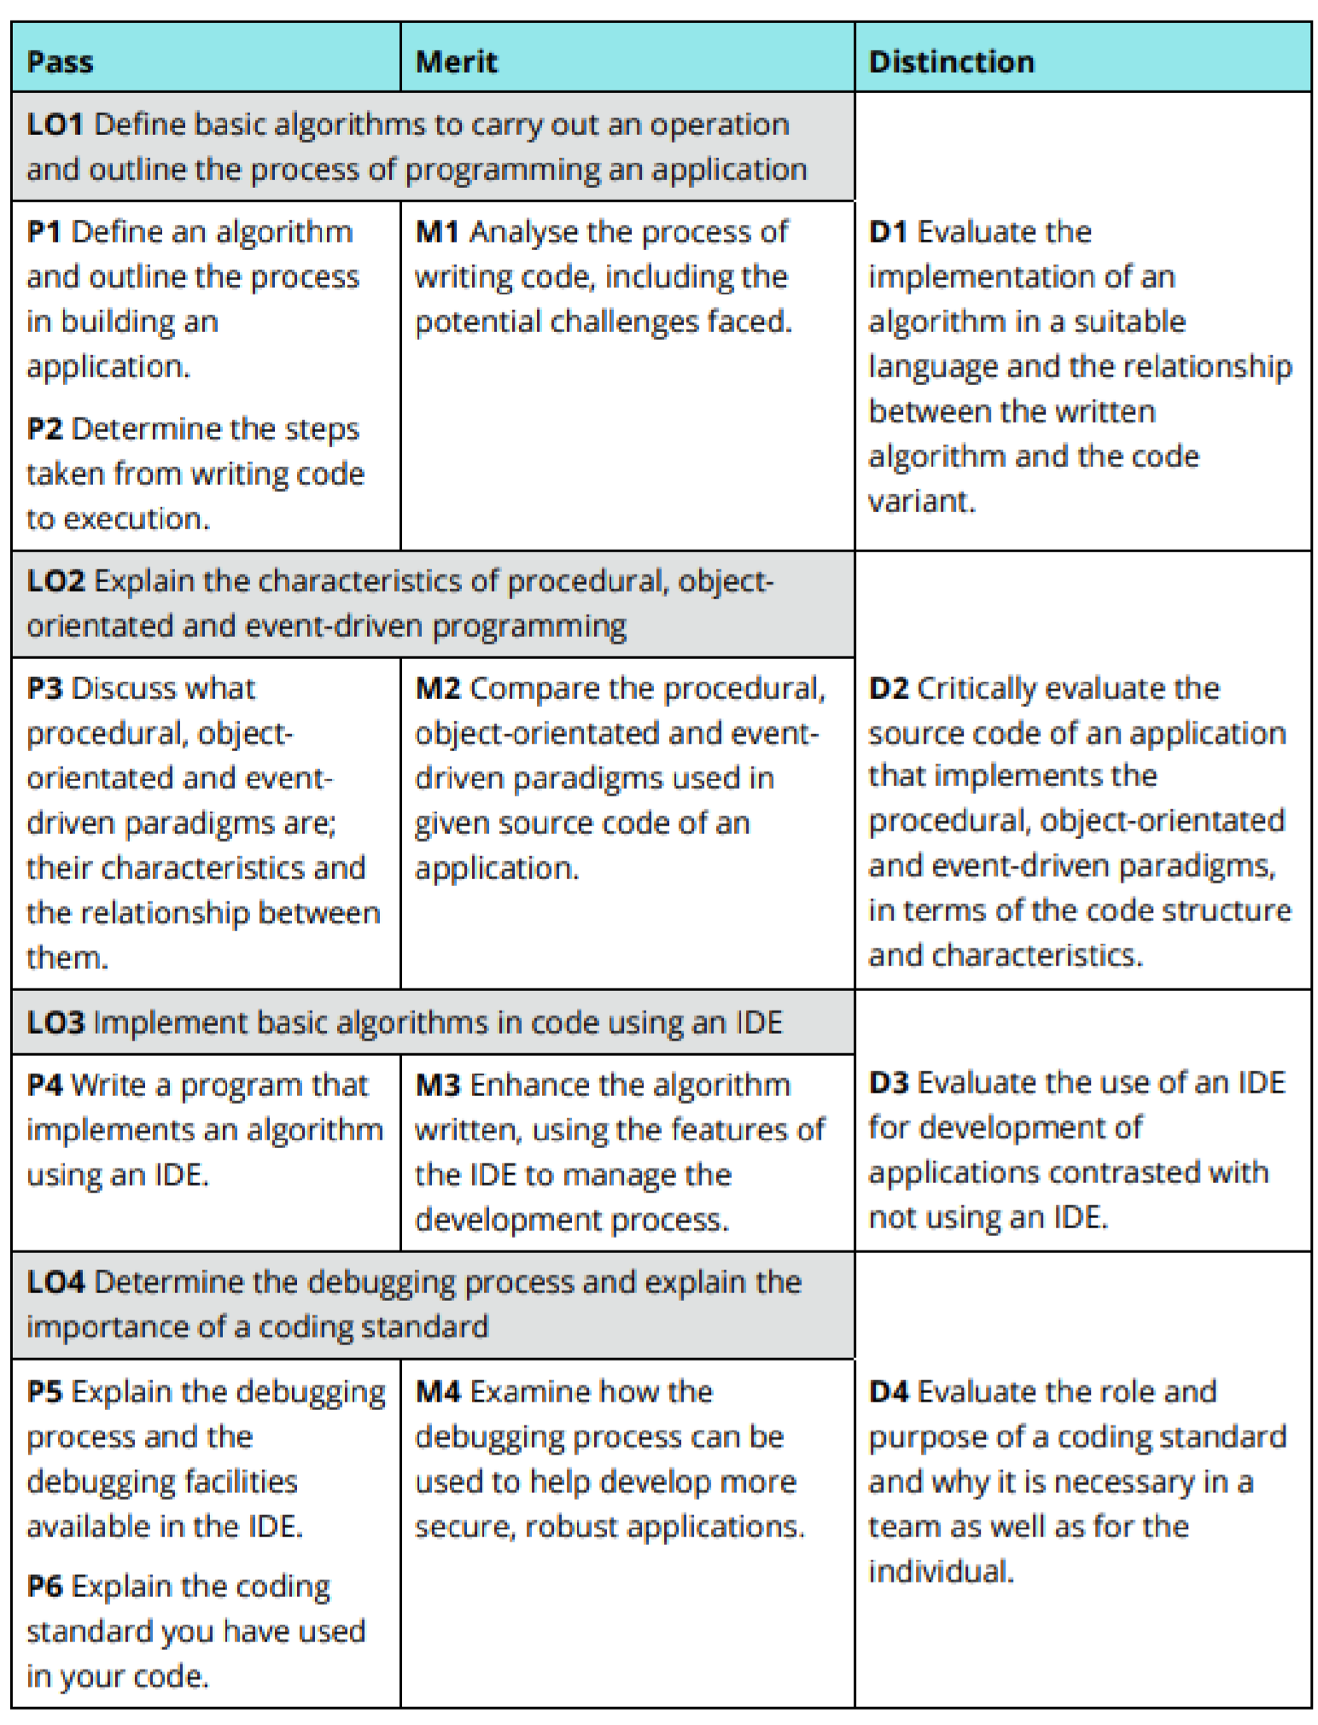

# Guidance for Students

**Deliverable**: Report Should be submitted one **soft copy** of word-processed Report.

**NOTE:**

* You should include the **COVER PAGE**, **Assessment Declaration form and Unit Review Plan** of this assignment when you submit your final report.

* If submitted after the extended deadline, the assignment will not be accepted whereas you shall be asked to go for a **NEW assignment**.

* Late Submission is not permitted until otherwise recommended by the Assessor /Course Coordinator.
* Plagiarism will be treated as a very Serious academic misconduct.

**Instructions to students:**

1. All assignment should comprise of the standard **Front Cover** given**. No other front page will be accepted.**

1. **Report Writing Guidelines:**

* 1. Every Assignment should have an **Introduction** and **Conclusion.**
  2. The standard **Table of Contents** should be generated.
  3. All the **Figures, Tables, Diagram** etc. should be numbered.
  4. **Main Heading** Font: **Arial**; Size 16
  5. **Sub heading:** Font**: Arial;** Size 14
  6. **Body text:** Font: **Arial**; Size 11
  7. **Paragraph:** 1.5 spacing
  8. **Margins:** **Top: 1”** **Bottom: 1”** **Left: 1”** **Right: 1”**
  9. **Header –** include the module name on the right hand side
  10. **Footer –** include the page number on the right hand side
  11. All sections should have continuity and pages should be clearly ladled.
  12. **References –** clear references for all the materials, books, articles, website etc should be given in accordance with Harvard Reference style (Harvard Anglia 2008